**Fall 2023: CS5720**

**Neural Networks & Deep Learning - ICP-1**

**CHARAN KUMAR KAMASANI**

**700754801**

1. **Write a python program for the following: – Input the string “Python” as a list of characters from console, delete at least 2 characters, reversethe resultant string and print it.**

1. **Write a program that accepts a sentence and replace each occurrence of ‘python’ with ‘pythons’.**

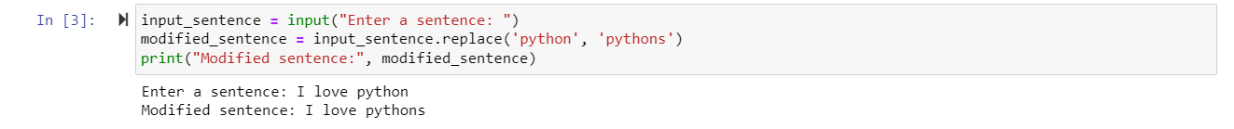

1. **Use the if statement conditions to write a program to print the letter grade based on an input class score. Use the grading scheme we are using in this class.**

